|  |  |  |  |  |  |
| --- | --- | --- | --- | --- | --- |
| **Project Tracking Number:** | 23A1070-117FP | | | | |
| **Project Title:** | Transient Multiphysics Simulation of Spent Fuel Repositories for Pebble-bed Reactors | | | | |
| **Principal Investigator:** | Derek Gaston | | **Directorate:** | NS&T | |
| **INL Co-investigator:** | Gordon Petersen | | **Directorate:** | NS&T | |
| **INL Co-investigator:** | Sebastian Schunert | | **Directorate:** | NS&T | |
| **INL Co-investigator:** | Alexander Lindsay | | **Directorate:** | NS&T | |
| **INL Co-investigator:** | Paolo Balestra | | **Directorate:** | NS&T | |
| **Initiative:** | Integrated Fuel Cycle Solutions | | | | |
|  | | | | | |
| **Budget Summary** | | **Funding Recipient** | | | **Budget ($)** |
| Fiscal Year 2023 | | Idaho National Laboratory | | | $350k |
| Fiscal Year 2024 | | Idaho National Laboratory | | | $350k |
| Fiscal Year 2025 | | Idaho National Laboratory | | | $350k |
| **Total:** | | | | | $1050k |

ABSTRACT

As the United States and the world work toward deploying advanced reactor concepts, we need to understand and optimize all parts of the fuel cycle. While many studies are ongoing to design new fuel types and reactor designs, relatively little attention is being paid to the backend of the fuel cycle: how the spent fuel will be transported and disposed of. This project aims to answer questions about the long-term viability of spent pebble-bed fuel in geological repositories through the research and development of high-fidelity, multiscale, multiphysics, simulation. By combining high-fidelity burnup/depletion simulation capability with detailed spent fuel cask calculations embedded within field-scale repository simulations over millions of years, we will create a test-bed for cask design, spent fuel operations, and repository siting for spent pebble-bed reactor (PBR) fuel.

The first year of this project saw the initialization of work on MOOSE (Multiphysics Object-Oriented Simulation Environment) based high-fidelity cask models, hydrological flow simulation, species transport, and detailed fuel burnup analysis. These models will form the basis of the project going forward, with each continuing to receive enhancements while also being coupled to each other to study a myriad of phenomenon and operations conditions.

# SCIENTIFIC AND TECHNICAL ACCOMPLISHMENTS CURRENT FISCAL YEAR

During the first year of the proposal, we undertook foundational work for the development of a high-fidelity, pebble-bed, spent fuel simulation capability. Simultaneous development began for fundamental models that will underpin all future development: high-fidelity cask simulation, detailed burnup analysis of a representative PBR, and geological flow and transport calculations. Each of these models is being developed utilizing the MOOSE [1] computational science platform. As MOOSE-based calculations, these models will naturally be able to be coupled to and embedded within each other in the future to enable multiscale, multiphysics, simulation of spent fuel repositories.

**MOOSE-based Simulation of Spent Fuel Repositories**

MOOSE is a full platform for development of parallel, high-fidelity, multiscale, multiphysics calculations. It provides a C++ finite-element/finite-volume framework, test-harness, documentation system, and many existing physics modules that allow for bootstrapping new physics applications. The finite-element/finite-volume framework provides an extensible, pluggable system for defining all parts of a multiphysics simulation: physics, boundary conditions, material properties, initial conditions, and even postprocessing. New simulation tools are created as suites of plugins that exercise these various interfaces. This method of development allows for a tremendous amount of code reuse and interoperability. Indeed, the physics modules [2-4] that come with MOOSE are, themselves, collections of plugins that new physics applications can immediately take advantage of to instantly add capabilities such as heat conduction, solid-mechanics, fluid-flow, chemistry, etc. The new tools under development within this project are heavily utilizing these existing capabilities, while extending and specializing them to cover the application space needed for predictive simulation of spent pebble-bed fuel.

In addition to the platform for creating new simulation tools, MOOSE also provides unique capabilities for coupling and/or combining them. Two MOOSE code systems in particular play a large role in this work: MultiApps and Transfers[5]. MultiApps provide a unique capability for executing many instances of physics applications in parallel on cluster architectures while Transfers move data between them. In this project, MultiApps will be used to execute the multiscale, multiphysics simulation for a full geological repository. One example hierarchical execution strategy is detailed in Figure 1. In Figure 1, the entire geological repository is modeled by the “main” app at the top. Embedded within that solve are many spent fuel casks which are performing simulations of flow, neutronics, and heat transport both within the cask and to the surrounding medium. Pebble simulations, with embedded TRISO (TRistructural ISOtropic) fuel particles, are then embedded within each cask simulation. At these lower levels, detailed heat conduction and convective heat-flux calculations provide the unique ability to resolve the true fuel temperature for feedback to the cask-scale neutronics calculations. With the MultiApp system all these simulations are running simultaneously, utilizing the transfer system for data movement up-and-down the scales.

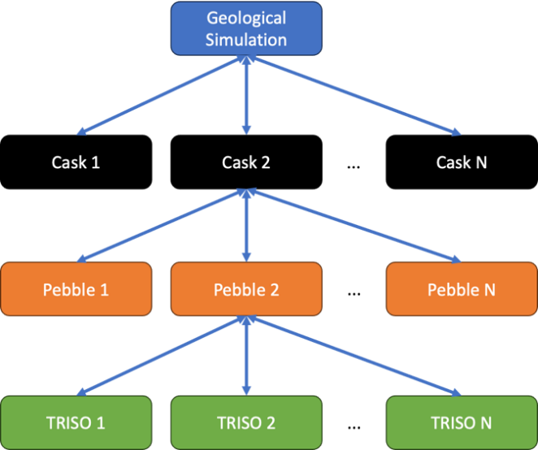

Figure . A hierarchical coupling strategy for multiscale, multiphysics spent fuel repository calculations performed using MOOSE MultiApps.

The above capability informs our approach: we are creating the individual simulation capabilities needed for each level of the hierarchy, and then we will utilize the MultiApp and transfer capabilities within MOOSE to tie them together to achieve a multiscale, multiphysics simulation of a spent fuel repository. The rest of this report outlines our efforts during the first year, which focused on the initial development needed in these physics solvers.

**Cask Geometry**

One primary task for this year was to identify the container geometry to use as the basis for the repository simulations. The initial canister design utilizes the Department Of Energy (DOE) Standard Canister [6] as a starting point for loading TRISO SNF in pebble form (Figure 2).

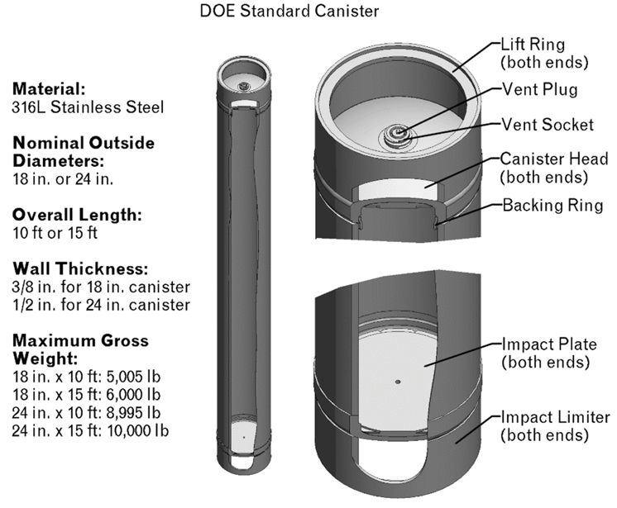

Figure : DOE Standard Canister depiction and dimensional data.

The DOE Standard Canister is a family of four different canisters with a diameter of 18 in. or 24 in. and a height of 10 ft and 15 ft. For this analysis the 24 in. x 10 ft DOE Standard Canister is utilized as the base model before increasing the diameter of the canister to 30 in. to match that of X-Energy spent nuclear fuel canister [7]. A theoretical canister configuration of pebbles containing TRISO particles is depicted in Figure 3.

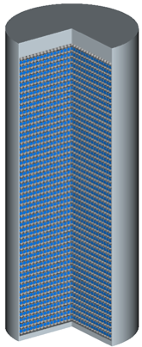

Figure . Theoretical canister configuration of pebbles containing TRISO particles.

For disposal in geologic repository, it is likely that the canisters will be confined in another canister/cask system (i.e. waste package) engineered to provide an additional barrier for the spent nuclear fuel to the surrounding conditions. The waste package will be modeled to contain a single canister and multiple canisters. Figure 4 shows a horizontal cross-section of multiple canisters containing pebbles in a larger waste package. These multi-canister systems will be the focus of future modeling effort.



Figure . Configuration of a waste package loaded with multiple canisters containing pebble- bed spent nuclear fuel.

**Multiphysics Burnup Calculations**

One of the important advancements by this project is the use of high-fidelity simulation to obtain the isotopic compositions of the pebbles discharged after they reach maximum burnup. Conventional tools for depletion analysis are not suitable for this purpose because of the movement of the pebbles trough the pebble-bed. For this reason, the Griffin[8] team developed a custom solver that allows tracking the isotopics in pebbles as they move through the core exposing them to different power levels and neutron spectra. The temperature at which every pebble burns changes the local spectrum. Therefore, the problem must be solved coupled with the thermal hydraulics to obtain detailed information about the fuel and moderator temperatures during the depletion. For this reason, we are coupling together the Griffin, Pronghorn[9], and BISON[10] MOOSE-based tools to achieve predictive depletion simulation. Pronghorn uses a porous media approximation to simulate the interaction between the coolant and the pebbles while BISON calculates the temperature within the pebbles and an average representative TRISO based on the burnup of the selected pebble.

The general 200MW PBR (GPBR200) model is based on open literature data but is similar to the designs considered for domestic deployment. In addition, the ART (Advanced Reactor Technologies) and NEAMS (Nuclear Energy Advanced Modeling and Simulation) DOE programs have created a version of the model which is to be hosted on the VTB (Virtual Test-Bed) [11] by the end of the fiscal year. These properties make it an ideal candidate for extension to meet the needs of this project. In the model we developed this year the fresh fuel has 15.5 % enriched fuel pebbles and is discharged at 164 MWd/kgHM,passing through the core on average six times. The calculation tracks the evolution of 295 isotopes plus 20 dummy isotopes (representative of isotopes with negligible cross-section but with significant decay heat) to calculate decay heat produced. The model geometry and components are described in Figure 5. The streamlines (the path that the pebbles follow) are approximated as straight lines instead of curving into the bypass flow. This has been taken into account reducing the total mass flow rate. Both these assumptions are not presumed to significantly affect the number density of the discharged fuel. In Figure 6 and Figure 7 some of the thermal hydraulic and neutronic results obtained from the model are shown. The thermal hydraulic results are in agreement with the literature and the neutronic results show the characteristic behavior expected by a thermal graphite moderated reactor.

Figure . GPBR200 mesh and model description.

Figure . GPBR200 thermal hydraulic results.

Figure . GPBR200 neutronics results.

Particular attention was dedicated to the decay heat calculation due to its importance for long-term storage. In Figure 8, three calculations have been performed to understand the best tradeoff between accuracy and calculation time. The first calculation “iso1700_decay_heat” is the resulting decay heat depleting the core using 1700 isotopes and it was used as reference calculation. The second calculation “iso295_decay_heat” was using just the 295 isotopes (the ones with cross sections) and was significantly faster than the 1700 isotope cases, however, it heavily underpredicted the decay heat. The last calculation, “iso295_pseudo_decay_heat,” is similar to the second one but has 20 pseudo isotopes to keep track of the decay heat generated from the missing isotopes. This third calculation runs as fast as the “iso295_decay_heat” but is as accurate as the results from “iso1700_decay_heat.”

Figure . GPBR200 Decay heat calculation at multiple fidelities.

These simulations of the GPBR200 are only the first step toward high-fidelity, multicycle modeling of pebble-bed reactors within this project. Looking toward the future we will incorporate higher-fidelity flow modeling, more accurate streamlines, fully three-dimensional calculations, and more accurate multiscale analysis. By computing an accurate initial condition for the fuel in our spent fuel casks, we will greatly increase the predictiveness of our repository model.

**Internal Cask Simulation**

As mentioned above, after fuel pebbles are cycled through a PBR they contain a large array of fission products. These fission products release energy in the form of heat through radioactive decay mechanisms. This heat generation drives many of the processes of interest when modeling spent fuel repositories, including: enhanced creep, corrosion, and degradation of canisters, water table movement, chemical reaction rates, recriticality, and geological barrier evolution. Due to the importance of these processes, in this first year we began development of a high-fidelity model for calculating the decay heat and its movement within a cask.

Simulating the effect of spent PBR fuel on a surrounding geological repository requires resolution of the physics within each fuel cask to use as the repository source term. Each modeled cask physics is now briefly described: Neutronics is the physics of radiation transport in time, space, and energy. Solving neutronics for the distribution of radiation within the cask allows one to compute one component of the heat source term to use in the thermal hydraulics calculation. Thermal hydraulics combines heat conduction, fluid mechanics, and thermodynamics to determine the distribution of temperature, fluid velocity, and pressure within each cask. Other relevant physics include thermomechanics to model the degradation of the storage casks over time, and mass transfer to model the leakage of any radioactive materials from the casks into the geological repository. The results from these cask simulations can then be used as source terms/boundary condition inputs into the simulations of the geological repository.

Cask simulations this year have focused on the thermal hydraulics aspect of the physics. Because the high-fidelity PBR burnup calculation that provides the source term for spent fuel in the casks is ongoing, cask radiation has not yet been modeled and arbitrary heat sources are used as placeholders. Figure 9 and Figure 10 show thermal hydraulics solutions (temperatures given by the color legend in Kelvin, and velocity fields indicated by the arrows) for preliminary simulations that utilize a rod-like spent fuel canisters embedded in a gaseous fluid. The purpose of these simulations is to create a template to use for thermal hydraulics problems that utilizes the MOOSE MultiApp system. In these results, each fuel canister is modeled as a sub, or child app, which solves the heat conduction equation given a heat source term that simulates decay heat. The fluid domain serves as the parent, or main app that utilizes the Transfers system to read the fuel rod temperatures and set up convective heat transfer boundary conditions at the fuel-gas interface. The parent app then solves the incompressible Navier-Stokes equations[12] that describe the flow of mass and energy in the fluid domain. The results show that decay heat from the spent fuel induces a natural convection loop in the fluid. With these simple results, the model complexity is next increased to simulate fuel in pebble form. To that end, points within the spent fuel canister are sampled. Utilizing the extreme flexibility of MOOSE, point heat sources are placed at each sample point to represent the decay heat from each fuel pebble. To account for the effect that pebble packing has on the gas flow, the porous incompressible Navier-Stokes equations are used to model thermal hydraulics in the cask. Results are shown in Figure 11. Although this simplified model does not utilize the MultiApp and Transfer systems, these systems will be needed in the future when coupling neutronics to thermal hydraulics.

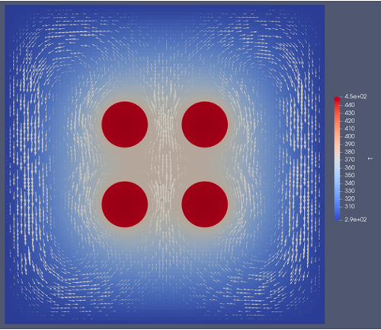

Figure . Convection loop around spent fuel rods (2D).

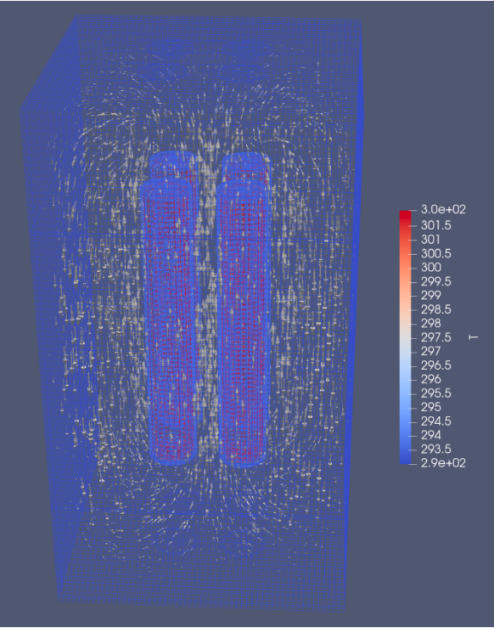

Figure . Convection loop around spent fuel rods (3D).



Figure . 2D axisymmetric porous flow cask simulation using 2,000 randomly placed pebbles as source terms.

These preliminary heat generation and flow results are only the first steps towards a high-fidelity, multiscale, multiphysics simulation of the internal state of canisters/casks. The next steps are to incorporate the isotopic information from the high-fidelity burn-up calculations, neutronics, further depletion, three-dimensional effects, energy movement through the system and to the surrounding geological material, and ultimately coupling to the larger geological repository calculation. By the end of the project we will be embedding hundreds of these high-fidelity calculations within field-scale geological repository calculations for multiscale simulation of repository performance.

Next year, the output from the GPBR200 simulation will be used as input for the storage cask model instead of relying on arbitrary placeholders. This entails using the isotopic composition of the depleted pebble-fuel as a material definition to compute decay heat via a neutronics (radiation transport) calculation. The resulting decay heat will be used as a source term in the cask thermal hydraulics simulation. Because neutronics are strongly affected by material properties called cross sections, and cross sections are strongly affected by material temperature, the neutronics and thermal hydraulics aspects of the cask must be solved iteratively until the cross sections and temperatures converge to a consistent solution. This physics coupling will be accomplished using the MultiApp and Transfer systems. Once complete, the results of the cask simulations can be used as input to the geological repository simulation.

**Geological Reactive Transport Simulation**

Combining natural and engineered materials, a multiple barrier system is employed within a geological repository to retain spent fuel and fission products. Within this system, reactive transport models (RTMs) play a vital role in understanding and assessing the coupling of thermal, hydrological, and geochemical processes within these containment barriers, which must withstand a range of temperatures and geochemical conditions while maintaining their integrity for millions of years. RTMs enable the evaluation of future repository behavior through sensitivity analyses and scenario modeling of various disposal subsystems. The containment of radioactive elements relies upon both a "near-field" engineered barrier and a "far-field" rock that is poorly conducive to radionuclide migration [13]. This year, in collaboration with University of Texas, Austin (UT), we began development of a detailed RTM that will form an important aspect of our field-scale repository models.

As explained above, nuclear waste is sealed in metallic canisters, with the ultimate goal of delaying groundwater contact with the fuel and fission products [14]. These canisters are typically surrounded by bentonite and/or cementitious buffers, with the surrounding geological formation inhibits the transport of contaminants away from the repository. The multiple barriers are designed to hydrologically contain the waste using low-permeability materials and/or chemically contain it using properties that favor the immobilization of radionuclides. Immobilization can be ensured by employing high sorption capacity materials or by creating chemically reduced conditions that minimize the transport of most actinides. These stringent containment measures allow radioactive isotopes to decay as much as possible before potential mobilization could occur. Figure 12 depicts a comprehensive multiple barrier system, commonly utilized in geological nuclear waste repositories. The illustration encompasses various levels of design, from the fundamental canister design to the more complex tunnel and overall repository design, which together serve to minimize the potential for radioactive waste release into the environment. This system operates across multiple scales and is a crucial component of performance assessment in nuclear waste management.

|  |
| --- |
| Figure . Multiple barrier system for geologic nuclear waste repositories. |

**Nuclear Waste Disposal Modeling**

Multiphysics modeling in nuclear waste disposal (NWD) management explores complex interactions of geochemical transport, fluid-flow, geomechanics, and energy balance. Advanced multi-region models enhance the understanding of advective and diffusive mass transfer processes. As developed above, fluid dynamics insights inform containment strategies, while geomechanical modeling aids in evaluating site stability and waste transport. Energy balance modeling, such as the detailed/canister cask models developed by this project, impacts waste behavior and geological formations. By incorporating high-performance computing and numerical methods, MOOSE significantly improves prediction accuracy and enables more effective groundwater protection and contaminant remediation strategies. The collaborative research effort between the University of Texas at Austin (UT Austin) and Idaho National Laboratory (INL) focuses on the development of a comprehensive multiphysics simulation for NWD. The primary objective is to establish a MOOSE-based application designed for accurate performance evaluation of geologic disposal of nuclear waste. This includes considering the intricacies of thermal-hydro-mechanical-chemical (THMC) processes. The collaboration's main goals encompass:

* Constructing the governing physics for the RTMs imperative for waste disposal multiphysics.
* Implementing effective formulation and discretization schemes, e.g., enriched Galerkin (EG) and the modified method of characteristics (MMOC), for flow energy and transport equations, ensuring mass and energy conservation [15, 16].
* Utilizing a posteriori error estimates for dynamic mesh adaptivity [17].
* Showcasing the effectiveness of the developed models via waste disposal scenarios.

During this first year, and in response to the limitations of conventional continuous Galerkin (CG) finite-element methods, including issues with grid orientation, numerical dispersion, and restrictive time-stepping, the team began development of MMOC and EG schemes. These approaches enable larger time-stepping without compromising simulation accuracy, mitigate overshooting at sharp interfaces, and ensure local mass and energy conservation at a reduced computational cost. We are utilizing known benchmark problems to illustrate these improvements. The team’s accomplishments thus far encompass the integration of multiphysics for NWD in MOOSE by coupling the porous flow and geochemistry modules, the design of EG finite-element discretization and fixed-stress split schemes for iterative coupling, and the development of an error estimator tailored for mesh adaptivity in EG and MMOC frameworks, compatible with the NWD's governing physics for flow, energy balance, and transport. Figure 13 exhibits the outcomes from ongoing benchmarking simulations that track the transport of soluble nuclides in groundwater. This crucial process aims to predict soluble nuclides' arrival times at a downstream river, illustrating their propagation and accumulation over time, thereby contributing valuable insights for the management and mitigation of NWD hazards.

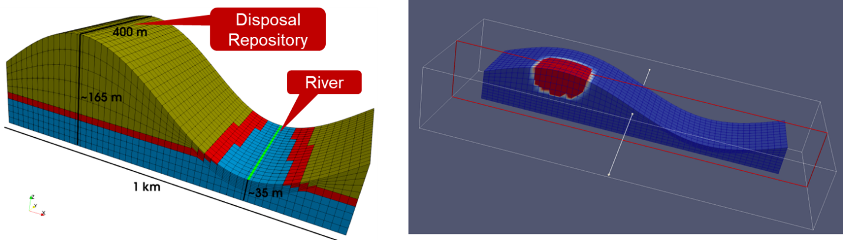

Figure . Ongoing simulation results showcasing the tracking of soluble nuclides' transport in groundwater over time. These methods will predict when and where these nuclear waste products will reach the downhill river, providing crucial insights for effective nuclear waste management.

**Future Field-Scale Research Focuses**

Future research aims to employ MOOSE-based applications to tackle complex NWD simulation problems. The primary objectives involve analyzing soluble radionuclide behavior, quantifying reaction kinetics, and studying environmental impacts on near-field barriers. This research plans to enhance predictive accuracy by concurrently modeling thermal. chemical, mechanical, and hydraulic processes, and by establishing more mechanistically detailed process models. The goal is to devise effective, safe methodologies for NWD by applying the MOOSE application to a diverse set of scenarios and problems, including for example:

* Transformation rates of insoluble U(IV) to more soluble oxidized U(VI) compounds under the influence of groundwater dissolved oxygen or oxidants produced by water irradiation.
* The impact of metal corrosion of iron canisters on the oxidative dissolution of UO2.
* Chemical interactions between cement-based and clay-based materials like bentonite and argillaceous rock.
* The effects of water salinity (pH) and temperature on in-situ chemical reactions.
* Spatio-temporal evolution of transport parameters.
* Evaluation of the implications of fracture sealing and tunnel stability for long-term performance.
* Simulations of different geological environments, ranging from pore scale to field-scale, for radioactive waste disposal.

# SCIENTIFIC AND TECHNICAL ACCOMPLISHMENTS PREVIOUS FISCAL YEARS

Not applicable because this is the first year’s progress report.

# BENEFITS TO DEPARTMENT OF ENERGY (DOE)

Advanced reactors represent a unique opportunity for the United States to build new reactors to meet our clean energy and environmental goals. Detractors of nuclear energy bring up the lack of a clear path for waste disposition. This project is aimed squarely at meeting our need for understanding the complete fuel cycle for these new reactors, accelerating their deployment. While this project is focused on spent pebble-fuel, the methodology, and the physics simulation capabilities will be broadly applicable across the full gamut of ART. Therefore, this proposal will have a broad impact across multiple reactor development and spent fuel programs.

One of the main objectives of the design of radioactive waste repositories is to provide adequate long-term isolation of the waste from the biosphere. Criticality events in a repository may jeopardize the repository’s ability to prevent the release of radionuclides to the environment. It is possible to specify measures that can be deterministically demonstrated to prevent criticality. However, their implementation becomes increasingly impractical for more highly enriched waste forms and for longer time periods of concern, making it important to model the effect of criticality events on repository performance. The ability to strongly couple the local behavior of waste packages to the overall repository performance is essential for a credible analysis of repository performance under complex failure scenarios. However, such a simulation capability does not yet exist.

Building this capability within the MOOSE framework puts INL in a position as a leader on repository simulation and allows specific capabilities to be developed in-house that may more adequately address the unique timeframes associated with long-term geologic disposal. While funding for disposal capabilities has taken a back seat to the efforts to conduct consent-based siting of an interim dry storage facility for commercial light-water reactor spent nuclear fuel, disposal is a necessary requirement in the nuclear fuel cycle. Having the capability to model multiple fuel types in several different geologic media, and couple the resulting consequences to other fuels and engineered barriers, could allow INL to significantly contribute to repository siting, selection, and performance analysis in the future.

# PROGRAM DEVELOPMENT ACCOMPLISHMENTS

The development of this project aligns with Spent Fuel Waste Disposition goals to provide a sound technical basis for the safety and security of long-term storage, transportation, and disposal or spent nuclear fuel and wastes from the nuclear energy enterprise. It specifically meets the goal in the *Spent Fuel & Waste Science and Technology (SFWST) Disposal Research R&D 5-year Plan* [18] to develop science and engineering tools to provide a sound technical basis for assurance that the United States has multiple viable disposal options available when a national policy is ready. We are currently involved in the EPRI (Electric Power Research Institute) dose modeling task group and we plan to continue this involvement and increase our involvement in international benchmark efforts over the course of this project.

# RESEARCH PLAN REVISIONS FOR NEXT FISCAL YEAR

Research plans for next year in each area were outlined in the respective areas within Section 1 of this report. The largest changes to the original research plan surround accident scenario definition. To take advantage of Ahmed Almetwally’s work and expertise during his time at UT Austin, the hydrological and reactive transport modeling was started in the first year, instead of waiting to year two. To make this possible, the development of accident scenario definitions has been delayed from year one to year two. Otherwise, the project is on-track with respect to the original timeline for capability development and research outputs.

# RESEARCH OUTPUTS

No research outputs were planned for this first year due to the required development of base technology needed to support the project. As seen in Section 1 of this report, that technology has significantly advanced, and we are now planning a conference paper submission to the American Nuclear Society winter meeting:

Patrick Behne, Derek Gaston, et. al. “Coupled neutronics, heat-conduction, and natural convection for high-fidelity simulation of pebble-bed spent fuel casks,” American Nuclear Society, Winter Meeting, 2023.

Our planned deliverables include:

Derek Gaston, et. al. “Initial Verification of a Multiphysics Repository Model for Pebble-Bed Used Fuel Disposition,” Nuclear Technology, October 2024

Derek Gaston, et. al. “Multiscale in Time and Space, Multiphysics Simulation of Pebble-bed Used Fuel Repositories,” Nuclear Technology, September 2025

In addition, the final deliverable for the project will be an open-source, transient, multiscale, multiphysics model published on the VTB. The openly available model will allow for continued interaction and interest from DOE projects, advanced reactor vendors, and universities.

# TALENT PIPELINE

This project is providing funding and career growth for a new-hire, early-career researcher at INL: Dr. Patrick Behne. Dr. Behne received his PhD in nuclear engineering from Texas A&M University in 2022 and was hired specifically to work on this project in December of 2022.

This project is also supporting Ahmed Almetwally, a PhD candidate at University of Texas (UT), Austin. Ahmed has a currently projected graduation date of December 2023. His professor, Dr. Mary Wheeler at UT Austin is also a key contributor to the project. Together, they are working on novel methods for simulating geological flows. The EG and advanced a posteriori error estimation capabilities they are developing will not only form the foundation for the geological repository calculation, but will be provided as open-source code to the entire community which is utilizing MOOSE.

# REFERENCES

1. Lindsay, A.D., et al., *2.0-MOOSE: Enabling massively parallel multiphysics simulation.* Softwarex, 2022. **20**.

2. Slaughter, A.E., et al., *MOOSE Stochastic Tools: A module for performing parallel, memory-efficient in situ stochastic simulations.* Softwarex, 2023. **22**.

3. Shemon, E., et al., *MOOSE Reactor Module: An Open-Source Capability for Meshing Nuclear Reactor Geometries.* Nuclear Science and Engineering, 2023.

4. Peterson, J.W., A.D. Lindsay, and F.D. Kong, *Overview of the incompressible Navier-Stokes simulation capabilities in the MOOSE framework.* Advances in Engineering Software, 2018. **119**: p. 68-92.

5. Gaston, D.R., et al., *Physics-based multiscale coupling for full core nuclear reactor simulation.* Annals of Nuclear Energy, 2015. **84**: p. 45-54.

6. Petersen, G.M. and B.W. Carlsen, *Neutron Absorber Considerations for the DOE Standardized Canister*. 2019, Idaho National Lab.(INL), Idaho Falls, ID (United States).

7. XEnergy, *Spent Fuel Management White Paper*, in *2023-XE-NRC-002, ML23011A234*. 2023.

8. Wang, Y., et al., *Rattlesnake: A MOOSE-based multiphysics multischeme radiation transport application.* Nuclear Technology, 2021. **207**(7): p. 1047-1072.

9. Novak, A., et al., *Pronghorn: A multidimensional coarse-mesh application for advanced reactor thermal hydraulics.* Nuclear Technology, 2021. **207**(7): p. 1015-1046.

10. Williamson, R.L., et al., *BISON: A flexible code for advanced simulation of the performance of multiple nuclear fuel forms.* Nuclear Technology, 2021. **207**(7): p. 954-980.

11. Giudicelli, G.L., et al., *The Virtual Test Bed (VTB) Repository: A Library of Reference Reactor Models Using NEAMS Tools.* Nuclear Science and Engineering, 2023: p. 1-17.

12. Lindsay, A., et al., *Moose Navier-Stokes Module.* Available at SSRN 4449290.

13. Ewing, R.C., R.A. Whittleston, and B.W. Yardley, *Geological disposal of nuclear waste: a primer.* Elements, 2016. **12**(4): p. 233-237.

14. De Windt, L. and N.F. Spycher, *Reactive transport modeling: a key performance assessment tool for the geologic disposal of nuclear waste.* Elements: An International Magazine of Mineralogy, Geochemistry, and Petrology, 2019. **15**(2): p. 99-102.

15. Lee, S., Y.-J. Lee, and M.F. Wheeler, *A locally conservative enriched Galerkin approximation and efficient solver for elliptic and parabolic problems.* SIAM Journal on Scientific Computing, 2016. **38**(3): p. A1404-A1429.

16. Almetwally, A.G., R. Podgorney, and M.F. Wheeler. *Using Enriched Galerkin as an Energy and Mass Conservative Scheme for Simulating Thermoporoelasticity Problems*. in *SPE Reservoir Simulation Conference*. 2023. OnePetro.

17. Girault, V., X. Lu, and M.F. Wheeler, *A posteriori error estimates for biot system using enriched galerkin for flow.* Computer Methods in Applied Mechanics and Engineering, 2020. **369**: p. 113185.

18. Sassani, D., et al., *SFWST Disposal Research R&D 5-Year Plan-FY2021 Update*. 2021, Sandia National Lab.(SNL-NM), Albuquerque, NM (United States).